**DLD Lab 08**

(Software)

**23K-2001**  
Muzammil Siddiqui  
BCS 2-J

**Exercise#1:**

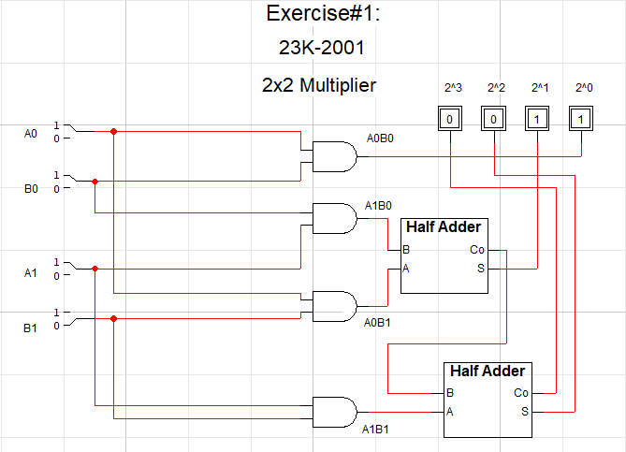

*Truth Table for Exercise#1:*

| **A0** | **A1** | **B0** | **B1** | **OUTPUT** | **IN DECIMAL** |
| --- | --- | --- | --- | --- | --- |
| 0 | 0 | 0 | 0 | 0000 | 0 |
| 0 | 0 | 0 | 1 | 0000 | 0 |
| 0 | 0 | 1 | 0 | 0000 | 0 |
| 0 | 0 | 1 | 1 | 0000 | 0 |
| 0 | 1 | 0 | 0 | 0000 | 0 |
| 0 | 1 | 0 | 1 | 0100 | 4 |
| 0 | 1 | 1 | 0 | 0010 | 2 |
| 0 | 1 | 1 | 1 | 0110 | 6 |
| 1 | 0 | 0 | 0 | 0000 | 0 |
| 1 | 0 | 0 | 1 | 0010 | 2 |
| 1 | 0 | 1 | 0 | 0001 | 1 |
| 1 | 0 | 1 | 1 | 0011 | 3 |
| 1 | 1 | 0 | 0 | 0000 | 0 |
| 1 | 1 | 0 | 1 | 0110 | 6 |
| 1 | 1 | 1 | 0 | 0011 | 3 |
| 1 | 1 | 1 | 1 | 1001 | 9 |

**Exercise#2:**

